Regional Climate

Vulnerability Assessment

Introduction

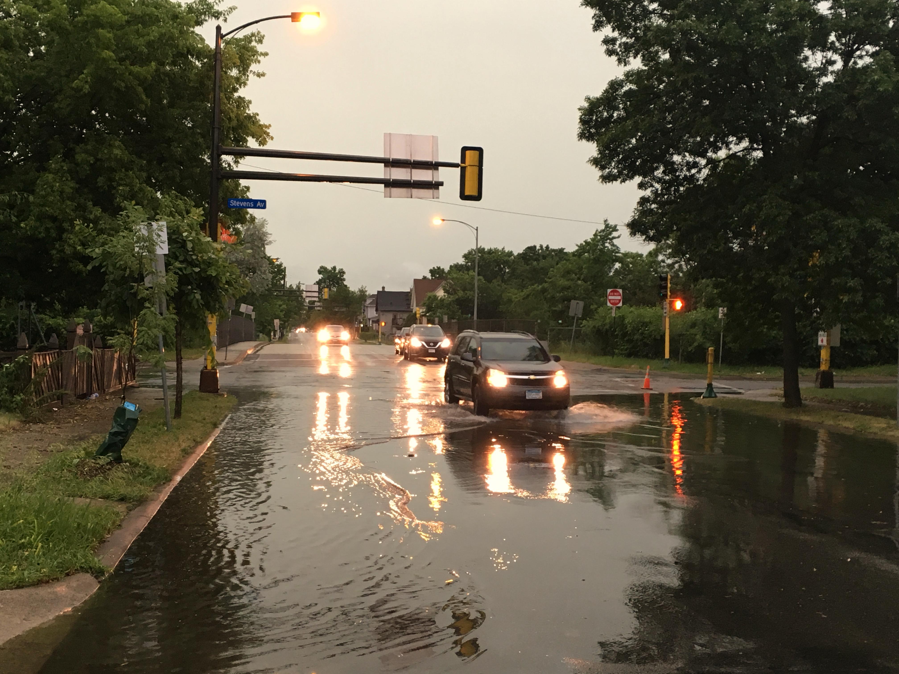White Bar Art

The Council’s mission is to foster  
efficient and economic growth for   
a prosperous metropolitan region

**Metropolitan Council Members**

|  |  |
| --- | --- |
| Alene Tchourumoff Chair Katie Rodriguez District 1 Lona Schreiber District 2 Jennifer Munt District 3 Deb Barber District 4 Steve Elkins District 5 Gail Dorfman District 6 Gary L. Cunningham District 7 Cara Letofsky District 8 | Edward Reynoso District 9 Marie McCarthy District 10 Sandy Rummel District 11 Harry Melander District 12 Richard Kramer District 13 Jon Commers District 14 Steven T. Chávez District 15 Wendy Wulff District 16 |

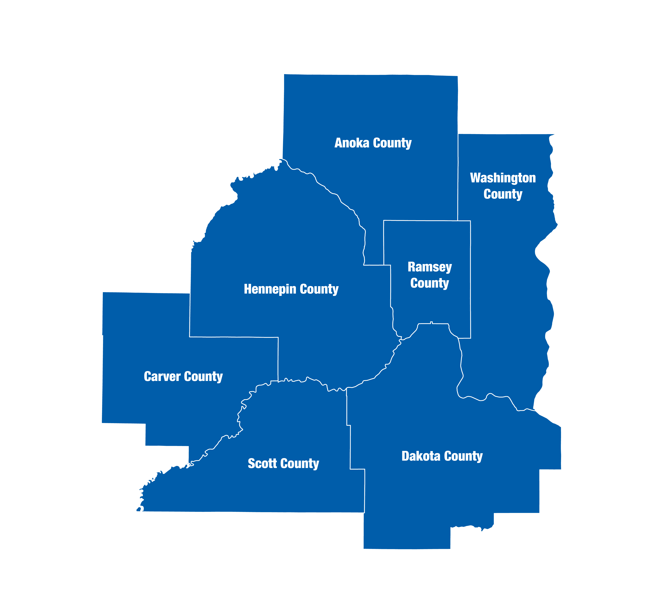

The Metropolitan Council is the regional planning organization   
for the seven-county Twin Cities area. The Council operates the regional bus and rail system, collects and treats wastewater, coordinates regional water resources, plans and helps fund regional parks, and administers federal funds that provide housing opportunities for low- and moderate-income individuals and families. The 17-member Council board is appointed by and serves at the pleasure of the governor.

On request, this publication will be made available in alternative formats to people with disabilities. Call Metropolitan Council information at 651-602-1140 or TTY 651-291-0904.

Table of Contents

Climate Vulnerability Assessment - Introduction 2

Climate Change in Minnesota 2

Extreme Rainfall 2

Why Focus on Localized Flooding? 3

Extreme Heat 4

Why Focus on Extreme Heat? 5

Project Purpose 6

Thrive Outcomes 6

Building in Resilience Land Use Policy 6

Technical Support 7

Project Need 7

Project Description 8

Focus Group 9

Deliverables 10

This effort includes the following deliverables: 10

CVA Project Limitations 10

Data 10

Discretion 11

Detail 11

Glossary of Terms and Acronyms Used the CVA 11

CVA Terms 11

Acronyms 13

References 14

# Climate Vulnerability Assessment - Introduction

## Climate Change in Minnesota

In his 2016 State of the State address, Governor Mark Dayton made the following observation about climate change: “From kids concerned that pond hockey doesn’t start until January to farmers trying to predict growing seasons, to folks wondering why this year’s March blizzards have turned into sixty-degree days, many thousands of Minnesotans have expressed their concerns about the growing impacts of climate change.” The Governor wasn’t speaking of distant ice caps and threats to polar bears, but rather to climate changes that we are experiencing regionally and locally, right here in Minnesota.

The most recent National Climate Assessment (NCA) produced by the U.S. Global Change Research Program (2014), synthesizes climate change impacts by sector and by region. The Midwest regional chapter of the NCA Report highlights current and future impacts related to climate change within the Twin Cities metropolitan region. The fourth NCA is set to be released in late 2018. The most pertinent statewide document detailing current and future likely climate change hazards is the Interagency Climate Action Team’s 2017 Report entitled *Adapting to Climate Change in Minnesota.*

Climatologists identify a range of climate-related hazards that can be exacerbated by climate change. This Climate Vulnerability Assessment (CVA) focuses on climate hazards related to **localized flooding** and **extreme heat.** More information can be found on the CVA webpage: <https://metrocouncil.org/CVA>

The long-term trends of our Minnesota climate have been changing outside the bounds of typical, temporary variations. In the years and decades ahead, winter warming and increased extreme rainfall will continue to be Minnesota’s two leading symptoms of climate change (see Table 1). Heat waves will also likely occur with more frequency, coverage, and duration.

|  |  |  |
| --- | --- | --- |
| Table 1. Climate Change Trends in Minnesota through 2099* | | |
| ***Hazard*** | ***Projections Through 2099*** | ***Confidence in Projected Changes*** |
| **Warming Winters** | Continued loss of cold extremes and dramatic warming of coldest conditions | **Highest** |
| **Extreme Rainfall** | Continued increase in frequency and magnitude; unprecedented flash-floods |
| **Heat Waves** | More hot days with increases in severity, coverage, and duration of heat waves | **High** |
| **Drought** | More days between precipitation events, leading to increased drought severity, coverage, and duration | **Moderately High** |
| **Heavy Snowfall** | Large events less frequent as winter warms, but occasional very large snowfalls | **Moderately Low** |
| **Severe Thunderstorms & Tornadoes** | More “super events” possible, even if frequency decreases |

*\*Source: ICAT (2017). Projected and expected trends among common weather hazards in Minnesota, and confidence that those hazards will change through the year 2099 in response to climate change. Graphic based on information from the 2014 National Climate Assessment.*

## *Extreme Rainfall*

A changing Minnesota climate has shown that more energy and more moisture in the atmosphere has the potential to create more rainfall.

Precipitation has been increasing in Minnesota over the last century, as shown in Figure 1 which illustrates historic annual precipitation.

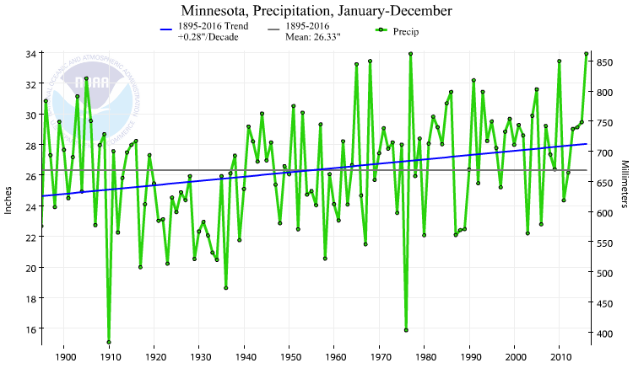

\**Source: NOAA National Centers for Environmental Information. Climate at a Glance: U.S. Time Series, Precipitation. (April 2017). Retrieved on April 27, 2017, from*[*http://www.ncdc.noaa.gov/cag/*](http://www.ncdc.noaa.gov/cag/)

Figure 1. Minnesota Annual Precipitation, 1895-2016*

The blue trend line in Figure 1 shows that annual precipitation amounts have been steadily increasing, which is compounded by increasing rainfall totals for specific, isolated storms. There has been a marked increase in what the State Climatologist terms, ‘mega rain events.’ These mega rain events are defined as a 6 inches or greater rainfall event covering at least 1000 square miles, with a peak rainfall amount of 8 inches or greater. Historically, fourteen of these mega rain events have been recorded since 1866, with half of these events occurring within the last fourteen years.

These extreme rainfall trends put a strain on stormwater infrastructure and other surface water conveyance or retention efforts. Given the fact that much of the stormwater infrastructure within the Twin Cities metro was designed to convey surface water based on technical standards and rainfall estimations adopted in 1960, the increasingly short, intense rainfalls present a challenge for communities and for the Metropolitan Council.

The National Climate Assessment states that the Midwest has already experienced a 37% increase in these larger rain events of 2.5 inches or greater (US Global Change Research Program, 2014). The extreme rainfall changes in the Midwest are only second to those of the Northeast US between 1958 and 2012.

### Why Focus on Localized Flooding?

From an asset management perspective, the financial implications of inaction are well researched and documented. According to the US Federal Emergency Management Agency (FEMA), federal insurance claims for flooding damage averaged $1.9 billion a year annually between 2006 and 2015, making flooding the costliest and most common type of natural disaster in the US (Planning Magazine, 2017).

This assessment focuses on the climate hazard of localized flooding for several reasons, including:

1. Increases in extreme rainfall have already occurred, and this trend shows the highest probability of continuing in the future (See Table 1).
2. Council assets are susceptible to vulnerabilities from potential localized flooding, including disruptions to the transit system, increase in inflow/infiltration to our wastewater infrastructure, adverse effects to water supply and water quality, and health and safety concerns for the region, for our customers, and for our employees.

Until now, no regional screening tool has been created to assess the potential impacts from localized flooding. The assessment allows the Council to screen regional assets for potential flood risk and subsequent vulnerability. In addition, the data analysis may provide leverage in advancing further regional and local analysis and tools. For example, this assessment may advance the interest in creating a regional stormwater dataset.

## Extreme Heat

The second area of this assessment focuses on extreme heat. Minnesota’s average temperatures have been increasing over the last century, as shown in Figure 3.

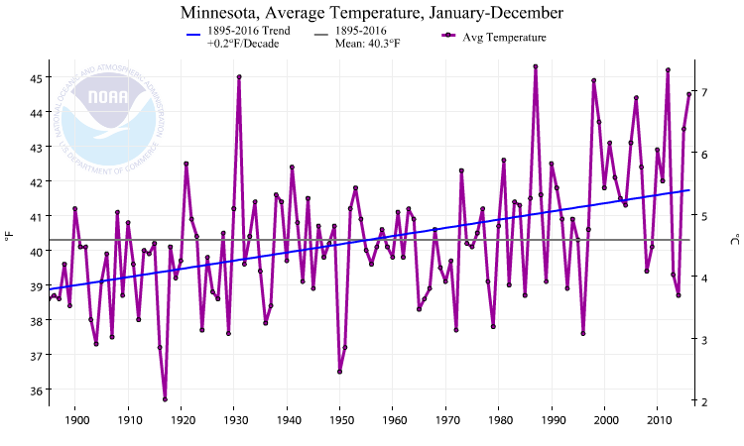*\*Source: NOAA National Centers for Environmental Information. Climate at a Glance: U.S. Time Series, Temperature. (April 2017). Retrieved on April 27, 2017, from*[*http://www.ncdc.noaa.gov/cag/*](http://www.ncdc.noaa.gov/cag/)

Figure 3. Minnesota Average Temperature, 1895-2016*

The blue trend line above shows a steady increase in average annual temperature over the last hundred years. It should be noted that the above graph does not demonstrate that Minnesota has seen an upward trend in heat waves, which is a period of unusually hot weather that typically lasts two or more days. Separating the data into average maximum and minimum temperatures, the increase in winter minimum temperatures becomes apparent in the blue trend line in Figure 4.

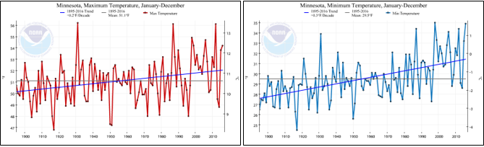

Figure 4. Minnesota Maximum and Minimum Temperatures, 1895-2016*

*\*Source: NOAA National Centers for Environmental Information. Climate at a Glance: U.S. Time Series, Maximum Temperature & Minimum Temperature. (April 2017). Retrieved on April 27, 2017, from http://www.ncdc.noaa.gov/cag/*

State Climatologists are highly confident that heat waves are likely to trend upwards in future summers in the state, from 2025 onwards. To create strategies to address extreme heat, researchers seek to identify the factors that exacerbate extreme heat. This investigation has shown that higher temperatures are amplified in areas with higher concentrations of pavement and impervious surface, as these areas tend to absorb the residual heat and hold that heat longer than vegetation would. This effect is called the Urban Heat Island effect, or UHI. Buildings can block the wind, reducing a mitigating effect on the extreme heat. The four components that make up the UHI are lack of vegetation, a high percentage of impervious surfaces, residual heat from cars and mechanical cooling, and building morphology.

Using remote sensing and satellite imagery, the Council has mapped an extreme heat event in the region, detailing the land surface temperature during a three-day heat wave, at noon on July 22, 2016. The map shows areas of extreme heat within the urban core area of the metro, while it also shows that areas near parks and water bodies are significantly cooler. It is important to emphasize that the data details land surface temperature, as opposed to air temperature. Air temperature data can provide a better measure of potential extreme heat impacts on human health. Due to data collection constraints with alternative data sets, the use of land surface temperature has ensured that this analysis has full metropolitan coverage. In addition, the land surface temperature can be helpful in identifying land use and built environment strategies to mitigate extreme heat in specific locations through a variety of site-specific interventions.

An extreme heat assessment will form part of the CVA as a separate chapter. Due to the limitations of this dataset in assessing impacts to specific regional assets, the assessment will evaluate correlations between heat and two primary factors: vegetation and the built environment. Another portion of the CVA focuses on human vulnerability to both localized flooding and extreme heat.

### Why Focus on Extreme Heat?

This assessment focuses extreme heat for several reasons, including:

1. Though heat waves have not shown an upward trend, heat waves are more likely to occur in the future, beyond the year 2025, according the Minnesota State Climatology Office (Table 1).
2. Human vulnerability to extreme heat is of concern for many stakeholders in the region, particularly county public health departments and agency partners.
3. The data created for this assessment allows us to investigate the relationship between the overall built and natural environment and the UHI effect.

Until now, no screening tool with regional coverage has been created to identify extreme heat through UHI. This work could provide leverage in advancing analysis and tools in this area. For example, the University of Minnesota has developed an extensive sensor network which measures the UHI using air temperature. The Council’s land surface temperature map may spur further research and expanded geographic coverage of the University’s research into UHI effect.

# Project Purpose

Recognizing the importance of climate change mitigation, adaptation, and resilience, the Metropolitan Council will use climate impacts as a lens through which to examine all of its work. *Thrive MSP 2040* (Thrive), the metropolitan development guide,articulates that the Council will look for opportunities to use both its operational and planning authorities to plan for and respond to the effects of climate change, both challenges and opportunities. The Council is dedicated to expanding its support to local governments in climate change planning.

The Sustainability and Equity outcomes within Thrive, as well as the Building in Resilience land use policy, provide policy direction to produce a regional Climate Vulnerability Assessment to plan for and manage Council infrastructure with the aim of enhancing the lifespan of Council assets through a strategic and proactive planning approach. Beyond extending the life of Council assets and infrastructure, outcomes from this project may reduce Council costs through efficient front-end planning and targeted maintenance.

## Thrive Outcomes

Thriveidentifies Sustainability and Equity as two of five desired outcomes that define a shared regional vision. Planning for sustainability means providing leadership, information, and technical assistance to support local governments’ consideration of climate change mitigation, adaptation and resilience. Climate change looms large as an issue with the potential to adversely affect the region in the absence of intentional and proactive planning to both mitigate and adapt to the impacts of a changing climate.

Thrive states that “The Metropolitan Council will use equity as a lens to evaluate its operations, planning, and investments, and explore its authority to use its resources and roles to mitigate the place-based dimension of disparities by race, ethnicity, income, and ability” (p. 41). Strategies to adapt to or mitigate against climate hazards should always address equity and achieve equitable outcomes. This aim is especially relevant in formulating strategies to reduce the impact of climate hazards. Research has shown that the most vulnerable populations are often the most impacted by the effects of climate change.

### Building in Resilience Land Use Policy

To achieve the five desired outcomes, the Council has identified seven land use policies to guide land use and regional development. The land use policy Building in Resilience seeks to develop local resilience to the impacts of climate change. The Council’s role in Building in Resilience includes identifying and addressing potential vulnerabilities in regional systems as a result of increased frequency and severity in temperature, precipitation, and extreme weather.

## Technical Support

“It is at the local level of government where most climate change impacts occur. Local jurisdictions are where streets and homes are flooded, where infrastructure is installed, where potable water is supplied, and where building permits are issued. As a result, ‘Main Street’ is the nexus for climate change action” (APA, 2011).

The development of a Climate Vulnerability Assessment (CVA) report and CVA tools (consisting of data sets, interactive mapping tools, and story maps) will complement the online [Local Planning Handbook](https://metrocouncil.org/handbook.aspx) through ensuring that an online resource of CVA is available for communities to assist with comprehensive planning and resilience planning more generally. The CVA will also improve the resource library within the *Local Planning Handbook* through promotion of CVA best practices, publicly available GIS data sets, and a suite of tools created for various audiences.

## Project Need

Beyond the specific policy language within *Thrive MSP 2040* which identifies and authorizes this project work, there is a business need for the project. The Climate Change Impacts and Risk Analysis Project conducted by the U.S. EPA, identifies the high costs of inaction to mitigate and adapt to the effects of climate change. This study suggests that there is an economic imperative to mitigate and adapt in the face of climate change, given the fact that mitigation can lessen future climate impacts, and adaptation prepares for climate impacts currently occurring and likely to occur in the future. If an organization, community, or business delays with resilience planning, the future cost of adaptation will likely increase (EPA, 2015).

Through its operation and planning roles, the Council is committed to reducing its GHG emissions (mitigation) while protecting natural resources. The Council operates and maintains wastewater infrastructure and plants, facilities, and a transit network. The Council also collaborates to plan for regional water quality and supply, the metropolitan transportation network, and regional parks and trails. Though many of these regional assets have been previously analyzed through a hazard mitigation or asset management process, they have not been measured through the lens of potential climate impacts and associated vulnerability.

|  |  |  |
| --- | --- | --- |
| **Table 2 –Summary of Regional Assets** | | |
| System or Focus | **Assets** | **Council Role** |
| Council-owned Housing | Housing | Owns & Maintains |
| Facilities | Buildings & Structures | Owns & Operates |
| Transit | LRT, Bus Network, Metro Mobility, & Commuter Rail | Owns & Operates; Collaboration with Stakeholders |
| Transportation | N/A | Planning & Collaboration with Stakeholders |
| Regional Parks & Trails | N/A | Planning & Collaboration with Implementing Agencies |
| Wastewater | Wastewater Treatment Plans, Interceptor Pipes, Lift Stations, Maintenance Holes | Owns & Operates |
| Water Supply | N/A | Planning & Collaboration with Stakeholders |

## Project Description

The CVA project supports the desired outcomes and land use policies identified in *Thrive MSP 2040* through the identification and analysis of potential vulnerabilities in regional systems resulting from increased frequency and severity of climate events.

The CVA is a tool that can assist in Council and community planning efforts in preparing and adapting to climate change because the CVA can reveal what systems (infrastructure, population, operations, etc.) are most vulnerable to currently occurring and, to some extent, expected climatic changes, depending upon factors such as asset exposure, sensitivity, and adaptive capacity.

The identification of potential vulnerabilities allows the Council and communities an opportunity to prioritize infrastructure improvements and maintain existing infrastructure investments. For example, extreme precipitation may cause localized flooding that impacts a particular transit route and transit stops. The Council may work with partners to enact operational and design strategies to reduce a potential vulnerability of the transit asset. Or, identification of a potential vulnerability may help a community focus its urban tree canopy planting in areas identified as most vulnerable to the extreme heat and its subsequent impacts.

There is no universal standard for conducting a CVA, and research suggests that results of such assessments can vary in terms of their utility and application (Graham McDowell et al, 2016). The following flowchart illustrates the Climate Vulnerability Assessment process:

Figure 5. Generalized CVA Process

Climate vulnerability assessments analyze climatic impacts on a series of chosen indicators or assets. Each asset has an adaptive capacity to a potential impact. This adaptive capacity is a product of the exposure to the impact and the sensitivity of the asset to the impact. The product of the exposure/sensitivity and potential impact/adaptive capacity is a measure of the indicator’s vulnerability. This measure of vulnerability can be used to create a targeted menu of adaptation strategies to better maintain, plan for, and manage Council assets.

Based on our choice of climate hazards, the diversity of assets, and data availability, we have defined the elements of the assessment equation in the following manner:

* **Exposure** – Exposureis a degree of climate stress upon a particular asset or indicator; it may be represented as either long-term change in climate conditions, or by a change in climate variability, including the magnitude and frequency of extreme events. Unless otherwise indicated in this assessment, sensitivity of a given asset is combined with exposure to produce a relative metric for asset risk.
* **Potential Impact** –The potential impact is a combination of exposure and sensitivity in light of a climate hazard. The potential impact can be offset by adaptive capacity, or its ability to bounce back.
* **Adaptive Capacity** – Adaptive Capacity is the ability of a system to adjust to changes, manage damages, take advantage of opportunities, or cope with consequences. This assessment does not consider adaptive capacity of assets, though this would provide a better estimate of specific vulnerability.
* **Vulnerability** –The degree to which a system is susceptible to, and unable to cope with, adverse effects of climate change, including climate variability and extremes. Vulnerability is a function of the character, magnitude, and rate of climate change and variation to which a system is exposed, its sensitivity, and its adaptive capacity.
* **Strategies** – Strategies are recommended actions that consist of best practices to preserve or enhance system assets. These strategies will most often encompass adaptation to climate change impacts, but some may include mitigation measures, like tree planting to offset GHG emissions.

Figure 6. Focus Group Participants

## Focus Group

This CVA will ultimately provide analysis tools for both the Council and for communities. Therefore, the Council reached out to communities for feedback on the scoping phase of the project. An invitation for the focus group was sent to all 188 jurisdictions in the region. Twenty-one participants attended the focus group in July 2016, representing 13 cities and one county (Figure 6). 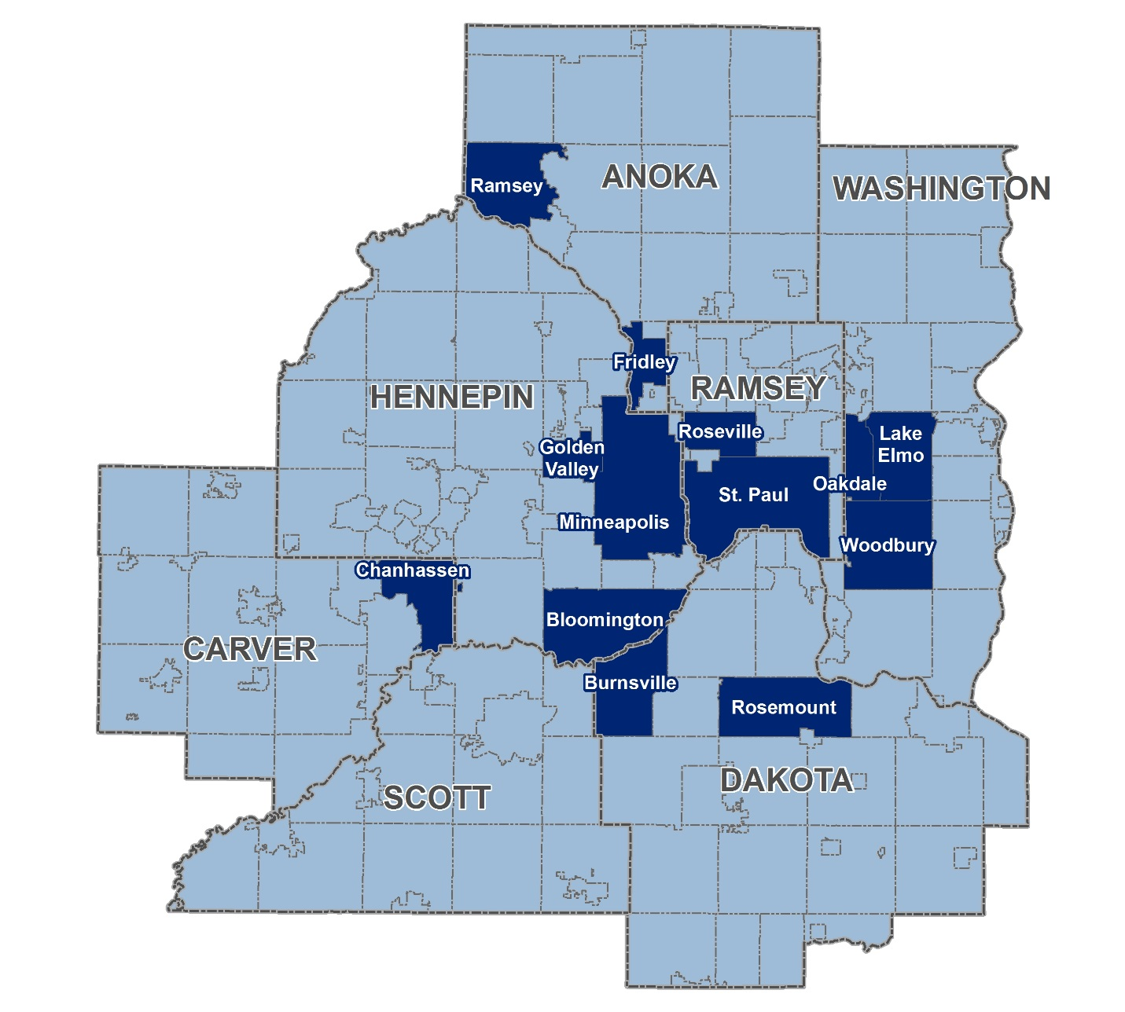The focus group participants provided helpful feedback for this project. The participants commented on the utility of the CVA in helping to foster conversation about, and supporting the need for, preparedness in their communities. They offered improvements for and criticisms of the project, potential application and its overall usefulness within city planning, adaptation strategies that could be employed throughout the region, and community needs for implementation.

The Focus Group also gave the Council insight into the CVA from a city’s perspective, rather than from a larger, regional scale. The Council will incorporate this local perspective to inform the remaining CVA project work. The participants also expressed interest in an ongoing, close collaboration between cities to strengthen the actions and dialogue on resilience and adaptation planning in the region.

## Deliverables

The key deliverables of this project include several CVA documents, separate parts and chapters. The project also consists of CVA tools (consisting of shape files, data sets, and interactive mapping tools) which will complement the online [Local Planning Handbook](https://metrocouncil.org/handbook.aspx) through ensuring an accessible resource of CVA for communities to assist with comprehensive planning and resiliency planning more generally. The CVA will also improve the resource library within the online Local Planning Handbook through the delivery of CVA chapters and publicly available GIS data sets. More information can be found on the CVA webpage: <https://metrocouncil.org/CVA>

### This effort includes the following deliverables:

1. Regional Climate Vulnerability Assessment
   * Climate Vulnerability Assessment Introduction
   * Part 1: Localized Flood Risk
     + Localized Flood Risk Introduction
     + Chapter 1: Transportation & Transit
     + Chapter 2: Regional Parks & Trails
     + Chapter 3: Wastewater
     + Chapter 4: Water Supply
   * Part 2: Extreme Heat
   * Part 3: Human Vulnerability to Localized Flooding and Extreme Heat
2. Integrate CVA tools into online *Local Planning Handbook*
   * Interactive, online mapping tools (data sets & shape files) available for public usage
   * Monitor and update GIS data, as required
3. Provide in person and/or self-guided education opportunities for the use of CVA in local comprehensive planning processes, climate mitigation and adaptation policies, and creation of resiliency action plans

## CVA Project Limitations

The project focuses on identification of vulnerable areas and infrastructure. However, give the regional scale of the assessment and other limitations, the assessment does not accomplish what a more localized, scaled down assessment can achieve. The reader should be aware of the project limitations regarding the data, discretion on the evaluation, and level of detail in the project, as detailed below.

### Data

* The project scope reflects data availability and data application. For instance, the absence of a region-wide stormwater dataset limits our ability to rigorously analyze potential localized flooding impacts.
* There is difficulty in obtaining reliable and verifiable data to inform the study, and the Council has refined the scope of this project in recognition of these constraints.
* The data used in this assessment is static. The analysis represents a snapshot in time and is not dynamic. The assessment will need to be renewed to remain current and relevant to everyday planning and investment decisions.
* The Council does not have data sources for locally-owned infrastructure. The Council’s work on CVA will primarily assess Council assets.

### Discretion

* The assigning of hazard thresholds was determined internally and is discretionary, based primarily through staff discussions and review of agency literature on, for instance, flooding hazards at various depths.
* The weighting of hazards in relation to exposure/sensitivity values was determined internally and is discretionary, varied by asset, and was decided through discussions with subject matter experts.

### Detail

* The basemaps are useful as a screening and planning tool for community or stakeholder use. We encourage users to perform more site-specific analysis to ground-truth data. Users are encouraged to create their own hazard thresholds, vulnerability weightings, and strategies based on their own priorities and scope.

# Glossary of Terms and Acronyms Used the CVA

## CVA Terms

**Adaptation** – Adaptation focuses on how to change policies and practices to adjust to the effects of climate change.

**Adaptive Capacity** – Adaptive Capacity is the ability of a system to adjust to changes, manage damages, take advantage of opportunities, or cope with consequences. This assessment does not consider adaptive capacity of particular assets, though this would provide a better estimate of specific vulnerability.

**Asset** –For the purposes of this analysis, Asset refers to a part of a system – for example, a piece of infrastructure, a bus route, or an arterial roadway.

**Bluespot** – The bluespot analysis is based on a Danish Road Institute study which uses a GIS fill tool to inundate topographical areas with water to assess areas potentially at risk of flooding. The Council assigned levels of hazard to different flood increments for its bluespot data layer.

**Climate** – Climate consists of the average weather conditions at a particular place over a long period of time.

**Climate Change** – A change in global or regional climate patterns that can be identified (e.g., by using statistical tests) and lasts for an extended period, typically decades or longer. According to the Intergovernmental Panel on Climate Change (IPCC), climate change may be due to natural internal processes or external forces such as modulations of the solar cycles, volcanic eruptions, and persistent anthropogenic changes to the composition of the atmosphere or in land use.

**Equity** – Equity connects all residents to opportunity and creates viable housing, transportation, and recreation options for people of all races, ethnicities, incomes, and abilities so that all communities share the opportunities and challenges of growth and change. For our region to reach its full economic potential, all of our residents must be able to access opportunity. Our region is stronger when all people live in communities that provide them access to opportunities for success, prosperity, and quality of life.

**Exposure** –Exposureis a degree of climate stress upon a particular asset or indicator; it may be represented as either long-term change in climate conditions, or by changes in climate variability, including the magnitude and frequency of extreme events. In the case of this assessment, sensitivity of a given asset is combined with exposure to produce a relative metric for asset risk.

**Flood Impact Zone** –Theremaining 3 flood hazards divide up the deeper bluespots and make up the Flood Impact Zone (FIZ). Primary are the first areas to fill with water (after the stormwater infrastructure has been overwhelmed). Secondary are the second areas to fill, and Tertiary are the last areas to fill.

**Flood Hazard** –For this assessment, the Flood Hazards refer to our groupings of bluespots into depth increments, from Shallow to Tertiary.

**Hazard Mitigation** –Hazard Mitigation is defined as any sustained action taken to reduce or eliminate the long-term risk to life and property from hazard events. It is an on-going process that occurs before, during, and after disasters and serves to break the cycle of damage and repair in hazardous areas.

**Indicator** – Indicator is used interchangeably with the term ‘asset.’ When the term ‘indicator’ is used, it typically refers to a particular demographic or social group.

**Localized Flooding** – Distinct from riverine flooding, localized flooding occurs when rain overwhelms drainage systems and waterways, making its way into basements, yards, and streets. It leads to multibillion-dollar damages but often lacks regulatory oversight and is far less studied.

**Mitigation** – Mitigation focuses on minimizing contributions to climate change – for example, reducing energy use that leads to greenhouse gas emissions.

**Potential Impact –** The potential impact is a combination of exposure and sensitivity in light of a climate hazard. The potential impact can be offset by adaptive capacity (bounce back).

**Resilience** – Resilience recognizes the difficulty of predicting what the impacts of climate change will be and emphasizes increasing our flexibility to survive and thrive regardless of how climate change develops. Resilience is the ability of a social or ecological system to bounce back after experiencing a shock or stress. Resilient systems are usually characterized by flexibility and persistence.

**Sensitivity** –The degree to which a built, natural, or human system will be impacted by changes in climate conditions. In the case of this assessment, sensitivity of a given asset is combined with exposure to produce a relative metric for asset risk

**System** –Systems that are analyzed are comprised of assets. For instance, the transportation system is comprised of different road classifications, all of which would be considered assets within the system.

***Thrive MSP 2040*** *–*Thriveis the Regional Development Framework for the Twin Cities Metropolitan Region. The policy document was adopted in 2014.

**Strategies** – Strategiesare recommendations based on best practices for asset management.

**Sustainability** – Sustainability means projecting our regional vitality for generations to come by preserving our capacity to maintain and support our region’s well-being and productivity over the long-term.

**Urban Heat Island Effect** – An urban heat island (UHI) is an urban area or metropolitan area that is significantly warmer than its surrounding rural areas due to human activities. The main cause of the urban heat island effect is from the modification of land surfaces. Waste heat generated by energy usage is a secondary contributor.

**Vulnerability** –The degree to which a system is susceptible to, and unable to cope with, adverse effects of climate change, including climate variability and extremes. Vulnerability is a function of the character, magnitude, and rate of climate change and variation to which a system is exposed, its sensitivity, and its adaptive capacity.

**Weather** – The daily conditions of the atmosphere in terms of temperature, atmospheric pressure, wind, and moisture.

## Acronyms

BNSF – Burlington Northern Santa Fe Railroad

BRT – Bus Rapid Transit

CFR – Code of Federal Regulations

CVA – Climate Vulnerability Assessment

DEM – Digital Elevation Model

DFIRM – Digital Flood Insurance Rate Map

GIS – Geographic Information Systems

GHG – Greenhouse Gas

FEMA – Federal Emergency Management Administration

FAA – Federal Aviation Administration

FIZ – Flood Impact Zone

FRA – Federal Railroad Association

ICS – Incident Command System

LiDAR - Light Detection and Ranging

LGU – Local Governmental Unit

LST – Land Surface Temperature

LRT – Light Rail Transit

MAC – Metropolitan Airports Commission

MC-MTS – Met Council - Metropolitan Transportation Systems

MSP – Minneapolis-St. Paul International Airport

MVTA – Minnesota Valley Transit Authority

NOAA – National Oceanic and Atmospheric Administration

NIMS – National Incident Command System

RBTN – Regional Bicycle Transportation Network

SOP – Standard Operative Procedure

SSPP – System Safety Program Plan

TCC – Transit Control Center

TPP – 2040 Transportation Policy Plan

TP40 – Technical Paper 40 - Rainfall Frequency Atlas

UHI – Urban Heat Island Effect

# 

# References

APA. (2011, April 11). *APA Policy Guide on Climate Change.* Retrieved from https://www.planning.org/policy/guides/adopted/climatechange.htm

Dayton, Governor Mark. (2016, March 9). *State of the State Address.* Retrieved from https://www.leg.state.mn.us/docs/2016/other/160350.pdf

EPA. (2015). *Climate Change in the United States: Benefits of Global Action.* (2015). Retrieved from https://www.epa.gov/sites/production/files/2015-06/documents/cirareport.pdf

ICAT. (2017). *Adapting to Climate Change in Minnesota: 2017 Report of the Interagency Climate Action Team.* Retrieved from https://www.pca.state.mn.us/sites/default/files/p-gen4-07c.pdf

McDowell, Graham, et al. (2016, March 4). *Community-level Climate Change Vulnerability Research: Trends, Progress, and Future Directions. Environmental Research Letters.* Retrieved from http://iopscience.iop.org/article/10.1088/1748-9326/11/3/033001/meta

Metropolitan Council. (2014). *Thrive MSP 2040 – One Vision, One Metropolitan Region.* Retrieved from https://metrocouncil.org/Planning/Projects/Thrive-2040.aspx

Metropolitan Council Environmental Services (MCES). (2016, May). *2015 Performance Report.* Retrieved from https://metrocouncil.org/Wastewater-Water/Publications-And-Resources/MCES-INFORMATION/MCES-Performance-Report.aspx

NOAA National Centers for Environmental Information. (2017, April). *Climate at a Glance: U.S. Time Series, Maximum Temperature & Minimum Temperature.* Retrieved from http://www.ncdc.noaa.gov/cag/

NOAA National Centers for Environmental Information. (2017, April). *Climate at a Glance: U.S. Time Series, Precipitation.* Retrieved from https://www.ncdc.noaa.gov/cag/

NOAA National Centers for Environmental Information. (2017, April). *Climate at a Glance: U.S. Time Series, Temperature*. Retrieved on from https://www.ncdc.noaa.gov/cag/

Planning Magazine. (2017). *Flood Ready.* Retrieved from https://www.planning.org/planning/2017/nov/floodready/

US Global Change Research Program. (2014). *National Climate Assessment.* Retrieved from http://nca2014.globalchange.gov/report

390 Robert Street North  
Saint Paul, MN 55101-1805

651.602.1000  
TTY 651.291.0904  
[public.info@metc.state.mn.us](mailto:public.info@metc.state.mn.us)  
metrocouncil.org

Follow us on:  
twitter.com/metcouncilnews  
facebook.com/MetropolitanCouncil  
youtube.com/MetropolitanCouncil